Jenkins Pipeline

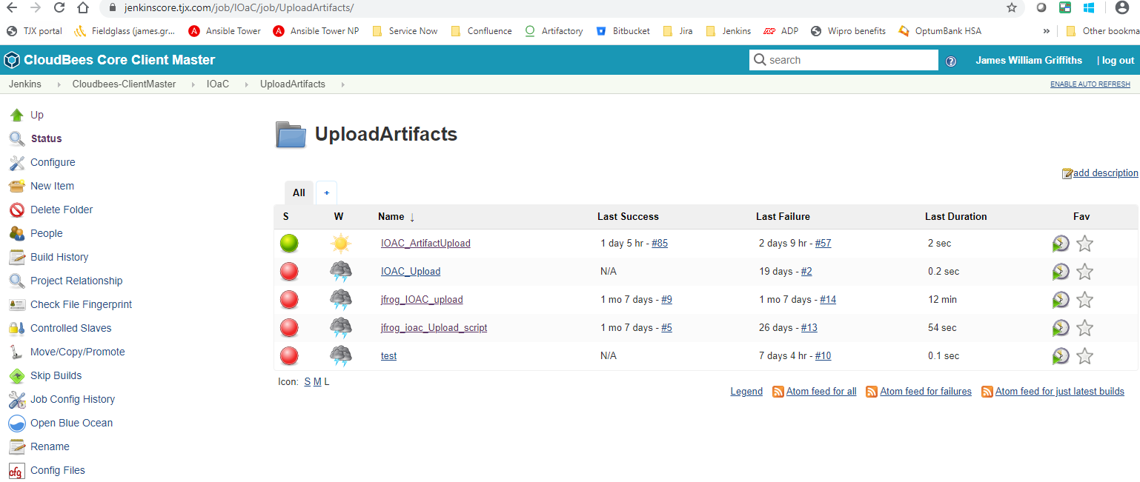

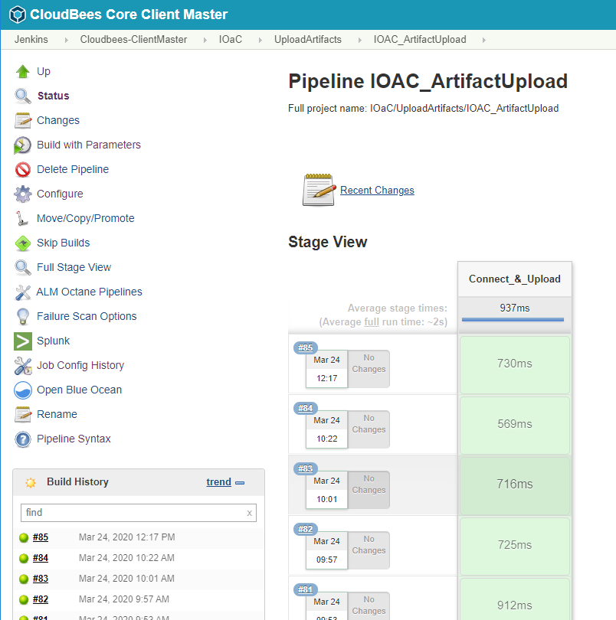

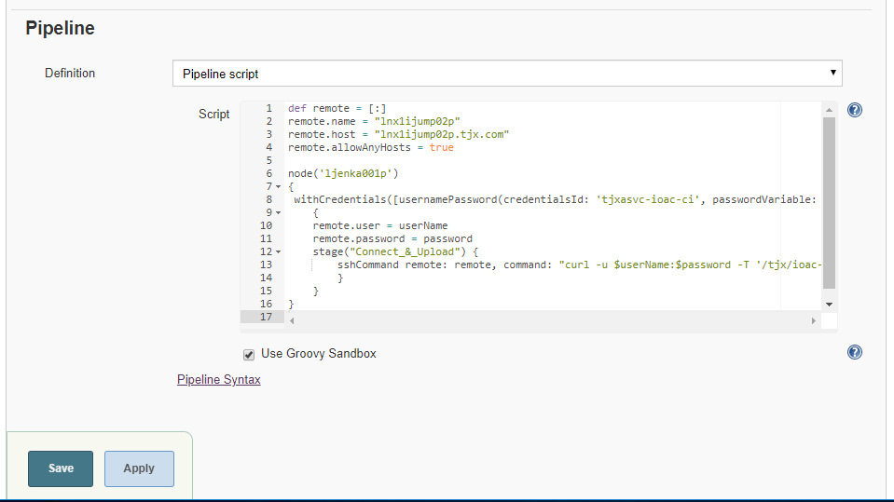

Pipeline script:

def remote = [:]

remote.name = "lnx1ijump02p"

remote.host = "lnx1ijump02p.tjx.com"

remote.allowAnyHosts = true

node('ljenka001p')

{

withCredentials([usernamePassword(credentialsId: 'tjxasvc-ioac-ci', passwordVariable: 'password', usernameVariable: 'userName')])

{

remote.user = userName

remote.password = password

stage("Connect_&_Upload") {

sshCommand remote: remote, command: "curl -u $userName:$password -T '/tjx/ioac-artifact-staging/${params.sourcePath}' 'https://jfrog.tjx.com/artifactory/${params.artifactoryPath}' -k"

}

}

}

Console output (failure case)

